|  |
| --- |
| KING PIE |
| WEB DEVELOPMENT 5020 |
| PROPOSAL |

|  |
| --- |
| Wanga Stuurman  ST10488602 |

Contents

King Pie 2

History 2

Mission 2

Vision 3

Website goals and objectives 3

Current website analysis 3

Proposed website features and functionality 3

Design and user experience 4

Technical requirements 4

Timeline and milestones 5

Budget 5

References 6

# King Pie

## History

The King Pie story is one filled with a rich history and a passion for good food. For 30 years, we have kept our promise to deliver world-class pies to royal fans. We proudly maintain the standards of quality and service for which we are renowned.

We have become a household name, thanks to our wide range of yummy eats and famous favourites like our hearty Pepper Steak Pie. We have something to satisfy everyone in the Kingdom. Our customers keep coming back because every bite is a royal delight. Our story began in 1990 when we opened our first store in Silverton, Pretoria. We dreamed of baking pies, filled with love and flavour – hearty food to warm the heart. This dream, now realised, is still our driving force.

We started in an open-style bakery where customers could see the kitchen action and indulge in the golden-bake smell drifting from the ovens. This proved to be a neighbourhood hit, and soon customers were queuing up for their piece of pie.

After three successful years, The King Pie Franchise Group was born, and we’ve been growing ever since. Today, we have over 300 franchised businesses and form part of The Bidvest Group Limited.

## Mission

* Brand: Through continuous development, ensure that the brand remains Vibrant, Energetic, Relevant & on Top of the Game.
* Leadership: Develop a world-class leadership team that is Innovative, Challenging, Accountable & Strategic in their Thinking & Actions.
* Culture: Foster a culture of Peak Performance & Accountability that is Service Orientated & driven by Customer Centricity.
* Business: Implementation of a Best Practice business model that: Ensures Sustainability, promotes long term Growth & Guarantees Consistency.

## Vision

To be world Class and Number 1 in all fields of endeavour:

* Franchise & retail
* Manufacturing, sourcing & procurement
* Marketing & sales
* Human resources & people’s practices
* Financial & commercial controls & practices

Target audience is the people, all people.

## Website goals and objectives

* Advertise products
* Provide valuable information
* Increase brand awareness
* Reach a larger market
* Increase sales
* Increase brand engagement

Key performance indicators: website traffic, average time on page, returning visitors, conversion rate, traffic source, and click-through rate.

## Current website analysis

Strengths: good information coverage, clear history and basic information, provided contacts details, franchise news coverage shown

Weaknesses: no online shopping or buy icon, the suggested online ordering system might be expensive due to extra charges

It might need its own online ordering system and maybe include an add to cart icon.

## Proposed website features and functionality

* Homepage
* About us page
* Contacts page
* Enquiry page
* Separate products/menu page

Users must be able to easily move from one webpage to another, do any desired goal if provided, and get feedback when enquired. The user must also receive the needed information about the business should they want to.

## Design and user experience

**Colour scheme**: green, purple and white

**Typography**: clear bold font and order of information depends on the page a person is visiting, however it will generally start with more important and in demand information.

**Layout and design**: hyperlink to other pages will remain at the top of all pages. The pages will be put in order and the products page will be one instead of also being available in the homepage. Purple will be the dominant colour as used in the current webpage. There will be images used to show the products and some to further explain the information.

## Technical requirements

o HTML

o CSS

o JAVASCRIPT

o VISUAL STUDIO CODE

o BROWSE

## Timeline and milestones

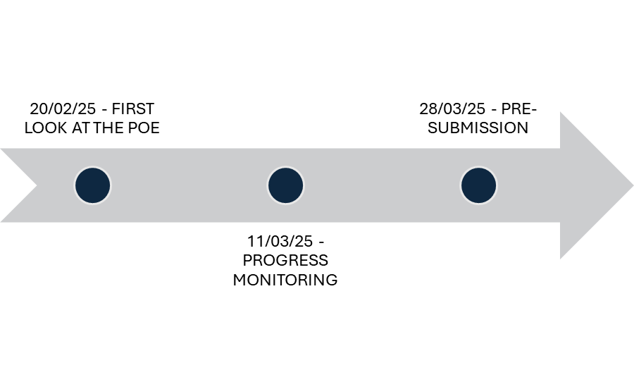

## Budget

Approximately R175 000 minimum

## References

King Pie. (2025). Welcome to King Pie – The Home of Delicious Royal. Available at: <https://www.kingpie.co.za/?gad_source=1&gclid=Cj0KCQjwkZm_BhDrARIsAAEbX1HNbY60E4Y7l9krA_P_JIf61uEZLe_vpP0jadkEyCCHZ7El5yLo2osaApYSEALw_wcB> (Accessed: 10 March 2025).